10 Common Software Architectural Patterns

Ever wondered how large enterprise scale systems are designed?

What is an Architectural Pattern?

The architectural patterns address various issues in software engineering, such as

- computer hardware performance
- limitations,
- high availability
- and minimization

of a business risk.

Some architectural patterns have been implemented within software frameworks.

Before major software development starts, we have to choose a suitable architecture that will provide us with the desired functionality and quality attributes.
Hence, we should understand different architectures, before applying them to our design

The Definition of Software Architecture

- An architectural pattern is a general, reusable solution to a commonly occurring problem in software architecture within a given context.
- Architectural patterns are similar to software design pattern but have a broader scope.

In this article, I will be briefly explaining the following 10 common architectural patterns with their usage, pros and cons.

- Layered pattern
- Client-server pattern
- Master-slave pattern
- Pipe-filter pattern
- Broker pattern
- Peer-to-peer pattern
- Event-bus pattern
- Model-view-controller pattern
- Blackboard pattern
- Interpreter pattern

1. Layered pattern

This pattern can be used to structure programs that can be decomposed into groups of subtasks, each of which is at a particular level of abstraction. Each layer provides services to the next higher layer.
The most commonly found 4 layers of a general information system are as follows.

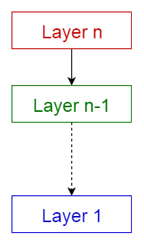

- Presentation layer (also known as UI layer)
- Application layer (also known as service layer)
- Business logic layer (also known as domain layer)
- Data access layer(also known as persistence layer)

Usage
- General desktop applications.
- E commerce web applications.

2. Client-server pattern

This pattern consists of two parties; a server and multiple clients. The server component will provide services to multiple client components. Clients request services from the server and the server provides relevant services to those clients. Furthermore, the server continues to listen to client requests.

Usage
- Online applications such as email, document sharing and banking.

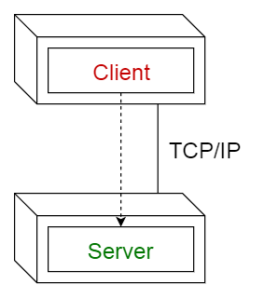

3. Master-slave pattern

This pattern consists of two parties; master and slaves. The master component distributes the work among identical slave components, and computes a final result from the results which the slaves return.

Usage
- In database replication, the master database is regarded as the authoritative source, and the slave databases are synchronized to it.
- Peripherals connected to a bus in a computer system (master and slave drives).

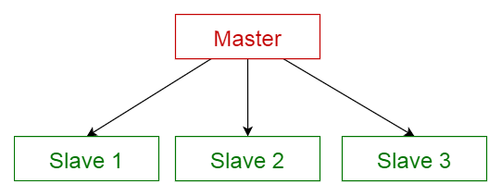

4. Pipe-filter pattern
This pattern can be used to structure systems which produce and process a stream of data. Each processing step is enclosed within a filter component. Data to be processed is passed through pipes. These pipes can be used for buffering or for synchronization purposes.

Usage
- Compilers. The consecutive filters perform lexical analysis, parsing, semantic analysis, and code generation.
- Workflows in bioinformatics.

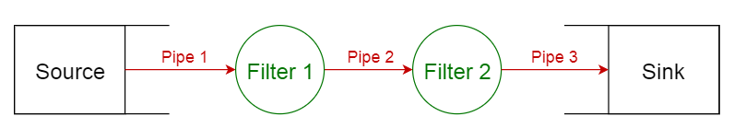

5. Broker pattern
This pattern is used to structure distributed systems with decoupled components. These components can interact with each other by remote service invocations. A broker component is responsible for the coordination of communication among components.
Servers publish their capabilities (services and characteristics) to a broker. Clients request a service from the broker, and the broker then redirects the client to a suitable service from its registry.

Usage
- Message broker software such as Apache ActiveMQ, Apache Kafka, RabbitMQ and JBoss Messaging.

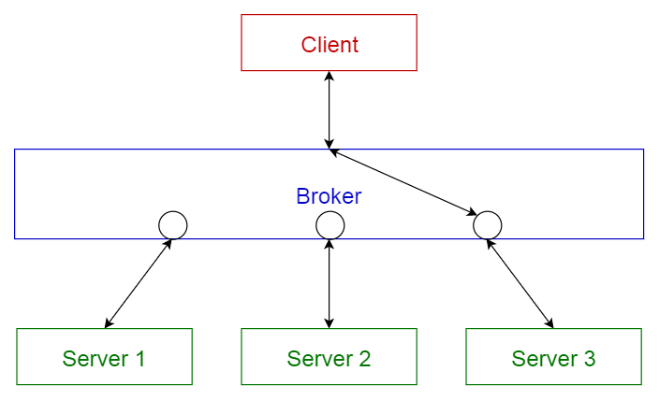

6. Peer-to-peer pattern
In this pattern, individual components are known as peers. Peers may function both as a client, requesting services from other peers, and as a server, providing services to other peers. A peer may act as a client or as a server or as both, and it can change its role dynamically with time.

Usage
- File-sharing networks such as Gnutella and G2)
- Multimedia protocols such as P2PTV and PDTP.

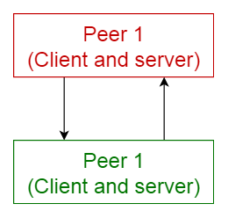

7. Event-bus pattern

This pattern primarily deals with events and has 4 major components; event source, event listener, channel and event bus. Sources publish messages to particular channels on an event bus. Listeners subscribe to particular channels. Listeners are notified of messages that are published to a channel to which they have subscribed before.

Usage
- Android development
- Notification services

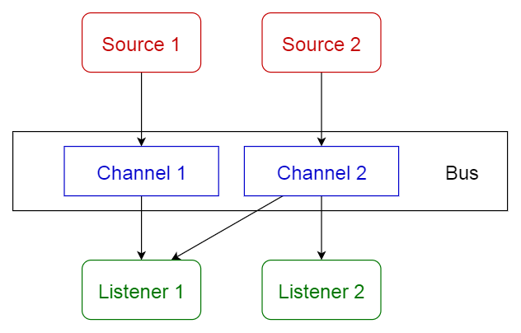

8. Model-view-controller pattern

This pattern, also known as MVC pattern, divides an interactive application in to 3 parts as,
- model — contains the core functionality and data
- view — displays the information to the user (more than one view may be defined)
- controller — handles the input from the user
This is done to separate internal representations of information from the ways information is presented to, and accepted from, the user. It decouples components and allows efficient code reuse.

Usage
- Architecture for World Wide Web applications in major programming languages.
- Web frameworks such as Django and Rails.

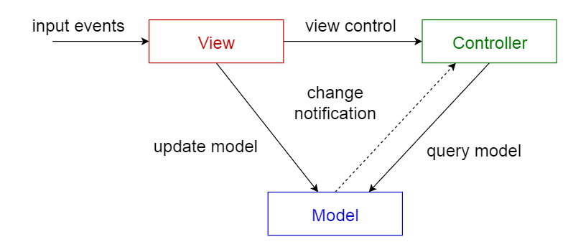

9. Blackboard pattern
This pattern is useful for problems for which no deterministic solution strategies are known. The blackboard pattern consists of 3 main components.
- Blackboard — a structured global memory containing objects from the solution space
- knowledge source — specialized modules with their own representation
- control component — selects, configures and executes modules.
All the components have access to the blackboard. Components may produce new data objects that are added to the blackboard. Components look for particular kinds of data on the blackboard, and may find these by pattern matching with the existing knowledge source.

Usage
- Speech recognition
- Vehicle identification and tracking
- Protein structure identification
- Sonar signals interpretation.

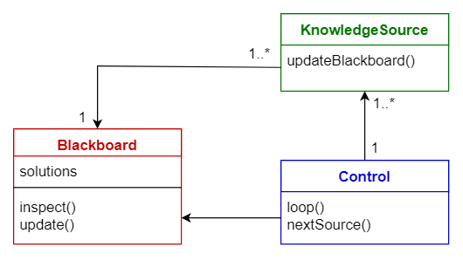

10. Interpreter pattern
This pattern is used for designing a component that interprets programs written in a dedicated language. It mainly specifies how to evaluate lines of programs, known as sentences or expressions written in a particular language. The basic idea is to have a class for each symbol of the language.

Usage
- Database query languages such as SQL.
- Languages used to describe communication protocols.

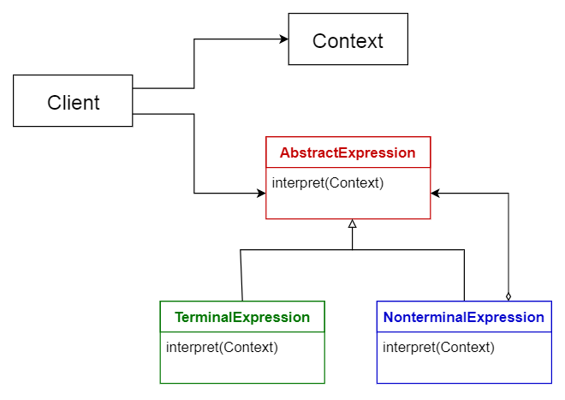

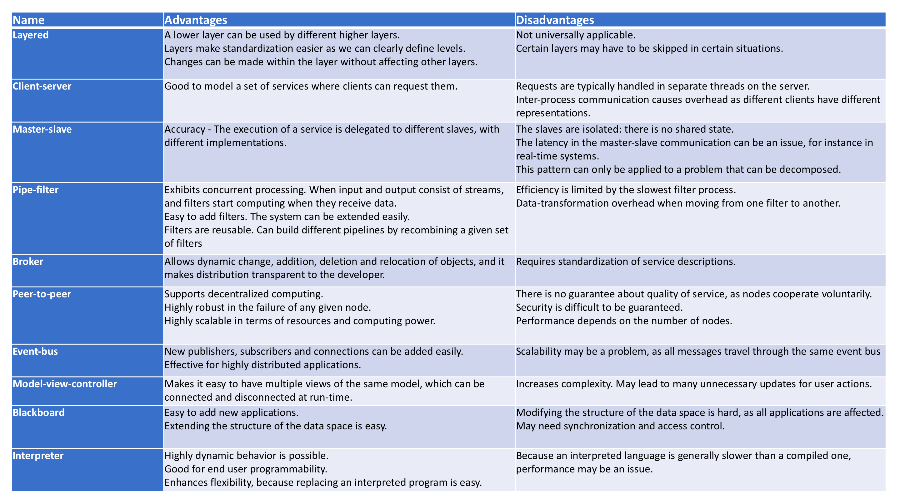

Software Architecture Patterns

Most people have probably heard of the term “MicroServices” before.

MicroServices is one of many other software architecture patterns such as

- Layered Pattern
- Event-Driven Pattern
- Serverless Pattern and many more.

MicroServices is one of many other software architecture patterns

1. Serverless Architecture

This element refers to the application solution that depends on third-party services to manage the complexity of the servers and backend management.

Serverless Architecture is divided into two main categories. The first is “Backend as a service (BaaS)” and the second is “Functions as a Service (FaaS).”

The serverless architecture will help you save a lot of time taking care and fixing bugs of deployment and servers regular tasks.
The most famous provider for serverless API is Amazon AWS “Lambda.”

What is serverless?

Serverless is the native architecture of the cloud that enables you to shift more of your operational responsibilities to AWS,

increasing your agility and innovation.

Serverless allows you to build and run applications and services without thinking about servers.

It eliminates infrastructure management tasks such as server or cluster provisioning, patching, operating system maintenance, and capacity provisioning.

You can build them for nearly any type of application or backend service, and everything required to run and scale your application with high availability is handled for you.

Why use serverless?

Serverless enables you to build modern applications with increased agility and lower total cost of ownership. Building serverless applications means that your developers can focus on their core product instead of worrying about managing and operating servers or runtimes, either in the cloud or on-premises. This reduced overhead lets developers reclaim time and energy that can be spent on developing great products which scale and that are reliable.

2.Event-Driven Architecture

This architecture depends on Event Producers and Event Consumers.

The main idea is to decouple your system’s parts and each part will be triggered when an interesting event from another part has got triggered. Is it complicated?

Let’s simplify it.
Assume you design an online store system and it has two parts. A purchase module and a vendor module. If a customer makes a purchase, the purchase module would generate an event of “orderPending” Since the vendor module is interesting in the “orderPending” event, it will be listening, in case one is triggered. Once the vendor module gets this event, it will execute some tasks or maybe fire another event for order more of the product from a certain vendor.

Microservices Architecture

Microservices architecture has become the most popular architecture in the last few years. It depends on developing small, independent modular services where each service solves a specific problem or performs a unique task and these modules communicate with each other through well-defined API to serve the business goal. I do not have to explain more just look at this image.

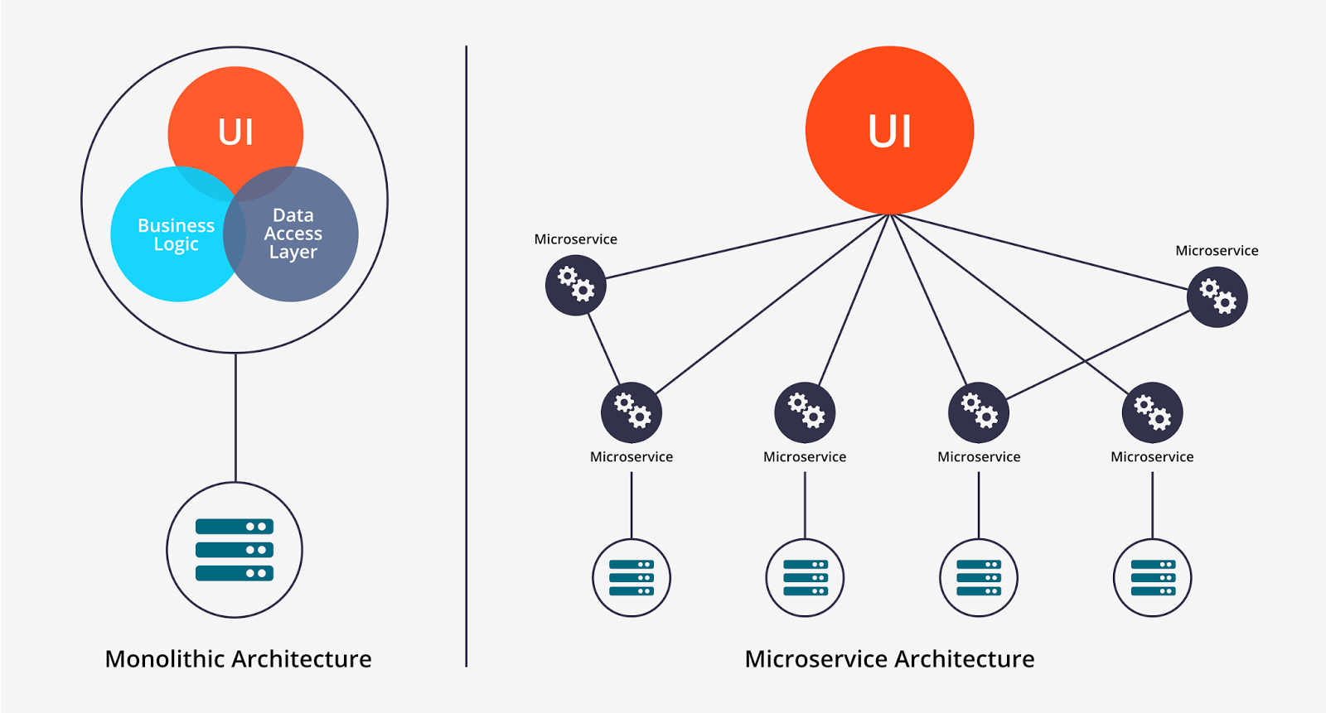

Software Design

While software architecture is responsible for the skeleton and the high-level infrastructure of a software, the software design is responsible for the code level design such as, what each module is doing, the classes scope, and the functions purposes, etc.

If you are a developer, it is important for you to know what the SOLID principle is and how a design pattern should solve regular problems.

SOLID Principles

*Design principles, we should keep in mind while writing our classes.
*They also form the best practices to be followed for designing our application classes.

1. Single Responsibility Principle
2. Open Closed Principle
3. Liskov's Substitution Principle
4. Interface Segregation Principle
5. Dependency Inversion Principle

1. Single Responsibility Principle
“One class should have one and only one responsibility”

we should write, change and maintain a class for only one purpose

* Model class : -
If it is model class then it should strictly represent only one actor/ entity

* service: -
we are writing service class then it should contain only that part of method calls and nothing else.
*Not even utility global functions related to module.
*Better separate them in another globally accessible class file.
- This will help in maintaining the class for that particular purpose,
- and we can decide the visibility of class to specific module only.

This will give we the flexibility to make changes in future without worrying the impacts of changes for another entity.

2. Open Closed Principle
“software components should be open for extension, but closed for modification”

* our classes should be designed such a way that whenever fellow developers wants to change the flow of control in specific conditions in application, all they need to extend our class and override some functions and that’s it.

*If other developers are not able to design desired behavior due to constraints put by our class, then we should reconsider changing our class

*I do not mean here that anybody can change the whole logic of our class, but he/she should be able to override the options provided by software in unharmful way permitted by software.

Eg:
Spring framework has class DispatcherServlet. This class acts as front controller for String based web applications. To use this class, we are not required to modify this class. All we need is to pass initialization parameters and we can extend it’s functionality the way we want.

3. Liskov’s Substitution Principle
“Derived types must be completely substitutable for their base types”

* fellow developer created by extending our class should be able to fit in application without failure.
*This requires the objects of your subclasses to behave in the same way as the objects of your superclass

EG:
In other words, if you have a class, Animal, with a MakeNoise() method.Then any subclass of Animal should reasonably implement MakeNoise().
Cats should meow, dogs should bark, etc.
What you wouldn't do is define a MuteMouse class(that throws IDontActuallyMakeNoiseException)
This violates the LSP, and the argument would be that this class has no business inheriting from Animal.

4. Interface Segregation Principle

“Clients should not be forced to implement unnecessary methods which they will not use”

ake an example. Developer Alex created an interface Reportable and added two methods generateExcel() and generatedPdf(). Now client ‘A’ wants to use this interface but he intend to use reports only in PDF format and not in excel. Will he be able to use the functionality easily?

NO. He will have to implement both the methods, out of which one is extra burden put on him by designer of software. Either he will implement another method or leave it blank. This is not a good design.

5. Dependency Inversion Principle
“Depend on abstractions, not on concretions”

* we should design our software in such a way that various modules can be separated from each other using an abstract layer to bind them together.

Eg : -
The classical use of this principle of bean configuration in Spring framework.
In spring framework, all modules are provided as separate components which can work together by simply injected dependencies in other module.
This dependency is managed externally in XML files.
These separate components are so well closed in their boundaries that we can use them in other software modules apart from spring with same ease. This has been achieved by dependency inversion and open closed principles. All modules expose only abstraction which is useful in extending the functionality or plug-in in another module.
These were five class design principles, also known as SOLID principles, which makes the best practices to be followed to design our application classes.

